HOME
- Landscape logo in menu bar
- Oval Contact button (if you can, could you add a bow on the corner of the button?)
- Change eyebrows to the green colour (b9e5ca) or try pink if we can intertwine it elsewhere
- Space out the heading to be 3 lines
- Change hero image to “boxed up cake with The Little Apron sticker”
- Add in a block under the hero before the “What we Offer” - white background and with a button
  - Wording: Have an event coming up?
Based in Hamilton, we’re your local for custom cakes. Whatever the occasion, we’ve got your cake creations covered - short notice or well in advance. [button to contact page - check availability].
- Bow background or cream - add
  - Wording: Looking for a cake on a budget?
We know cakes can get expensive, so we’ve created options to suit different budgets without compromising on style or taste. Have a look through our options or contact us to chat about what you’re after [button to signature cakes#budget - budget-friendly options].
- Move the green banner before the footer, underneath budget block
  - Change the words to a definition quote in italics -
“The Little Apron Cakes: Handmade cakes designed to make every celebration feel a little more special. Birthdays, weddings, gender reveals, baby showers - you name it, we have cake for it.”

FOOTER
- Edit my phone number - 027 347 0648
- Edit my email - hello@thelittleapron.co.nz
- Social links
- In my green colour, grey or the pink (if we’re intertwining pink) in scripted/handwritten front can you add
Baked by Hand,
With Love
For You

OUR STORY
Hi, I’m Cushla [handwritten font]
Chief baker, decorator, administrator, content creator and more for The Little Apron. There was once a time, when I was just a little girl learning to bake.

Where it started [photo of me on the step ladder]
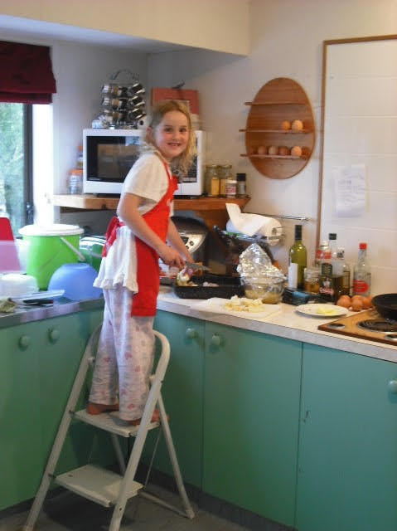

*Arrow*

And it grew to something more, when I wanted to take classes but there weren’t many around, so we reached out. There were many people who took the time to teach me properly.
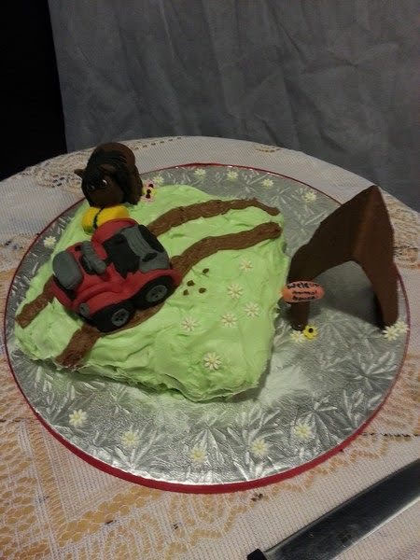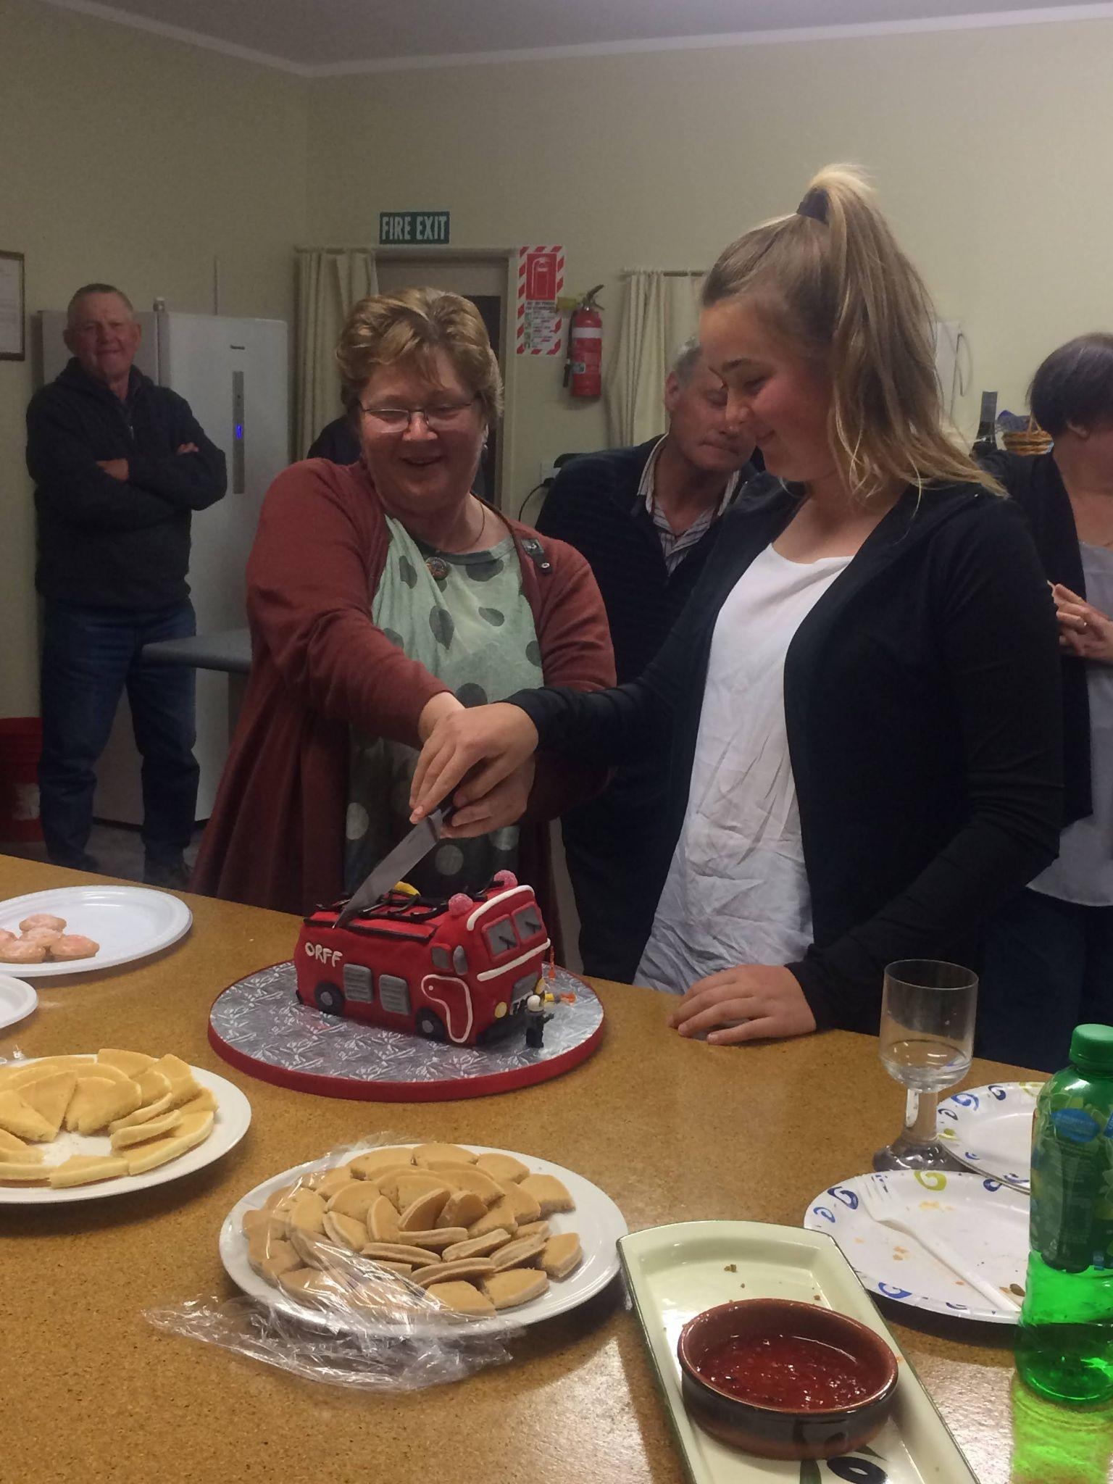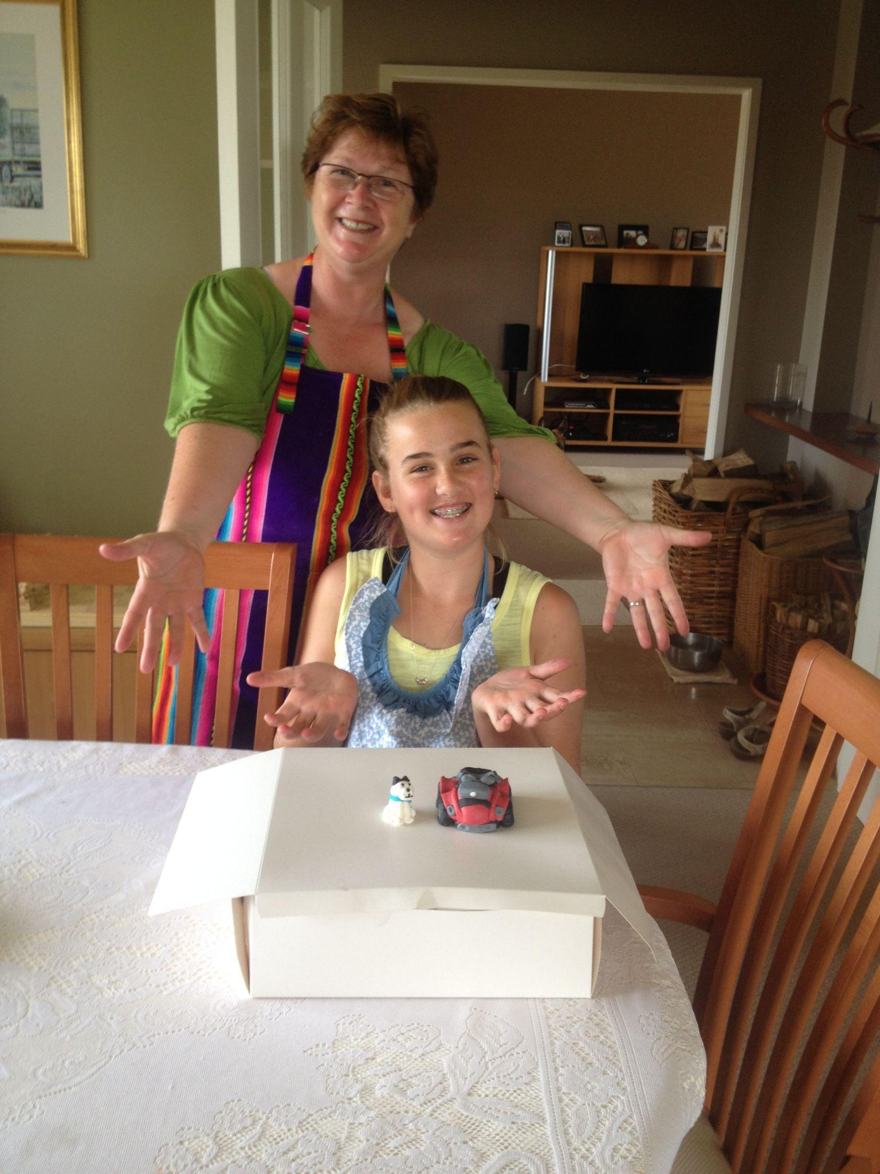
[fondant making birthday event, fondant cakes, fire truck cake, owls, Mums cake]

Then, at 15, I landed my dream first job at a dessert restaurant called The Sugar Shed.
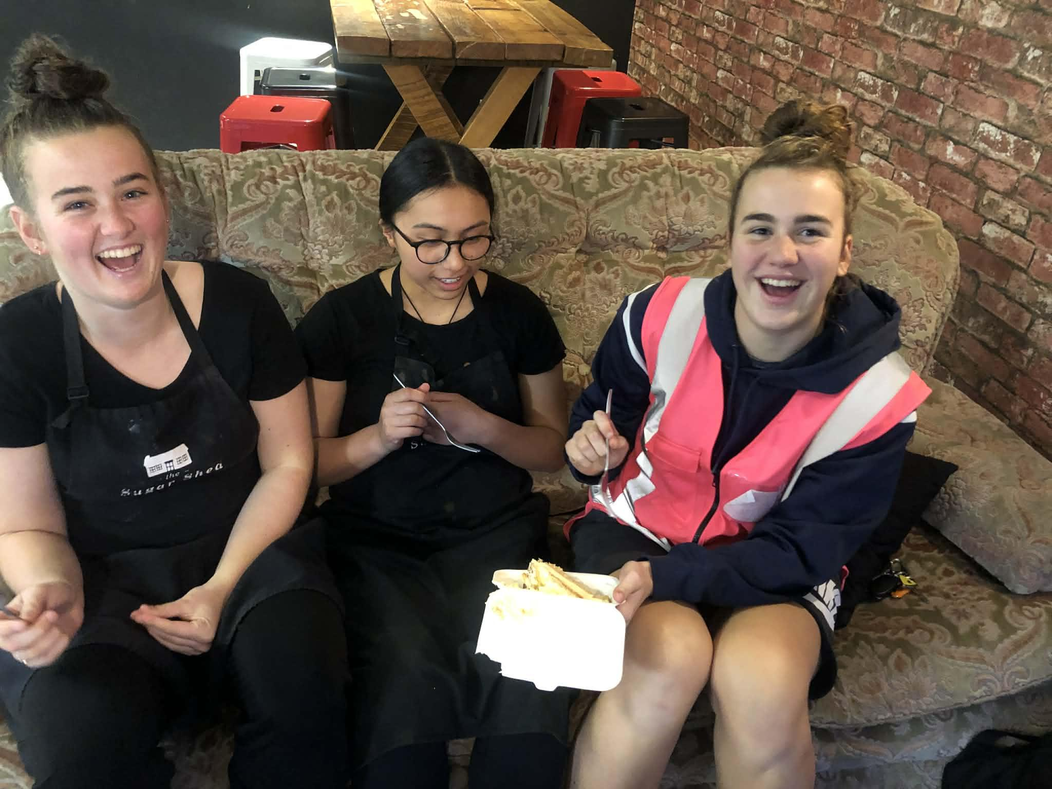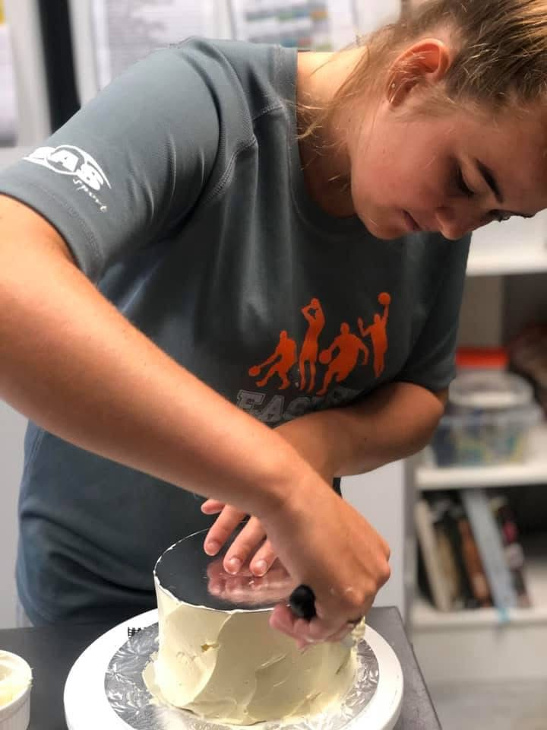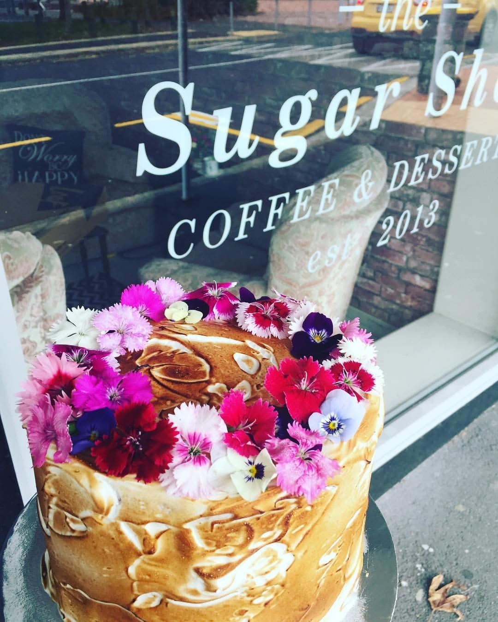
[photo of Liv and I, testing the food, some of the cakes we created with Sugar Shed in background)

That’s where I learnt the art of buttercream cakes
*Arrow*

I saved up my first few paychecks and bought my very first stand mixer. [photo of me with my stand mixer
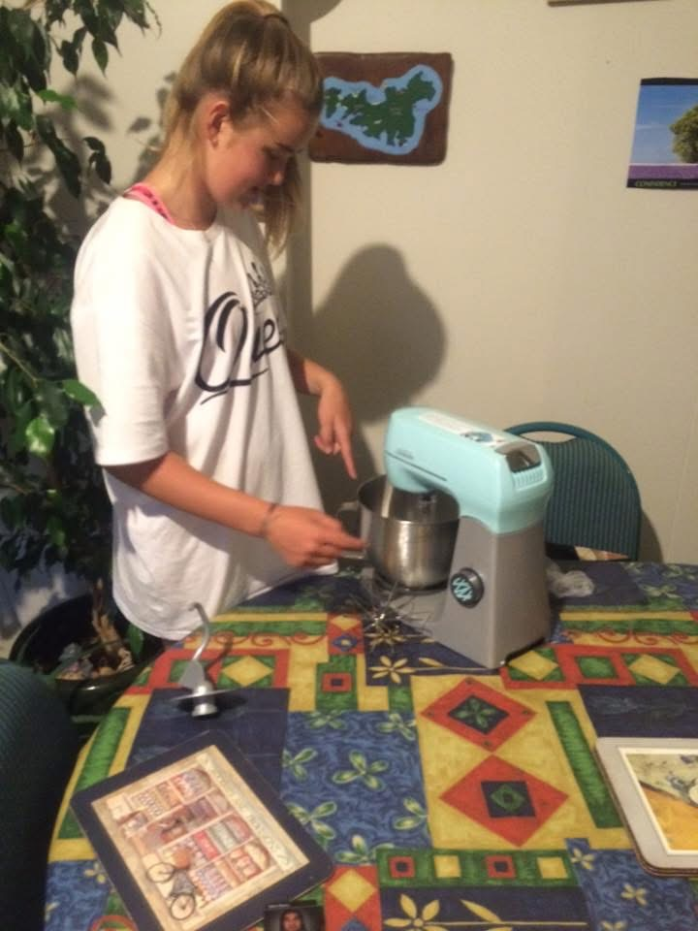

For the last 5 years, this has all lived under CushsCreations.
[photo of cush in CushCreations apron]
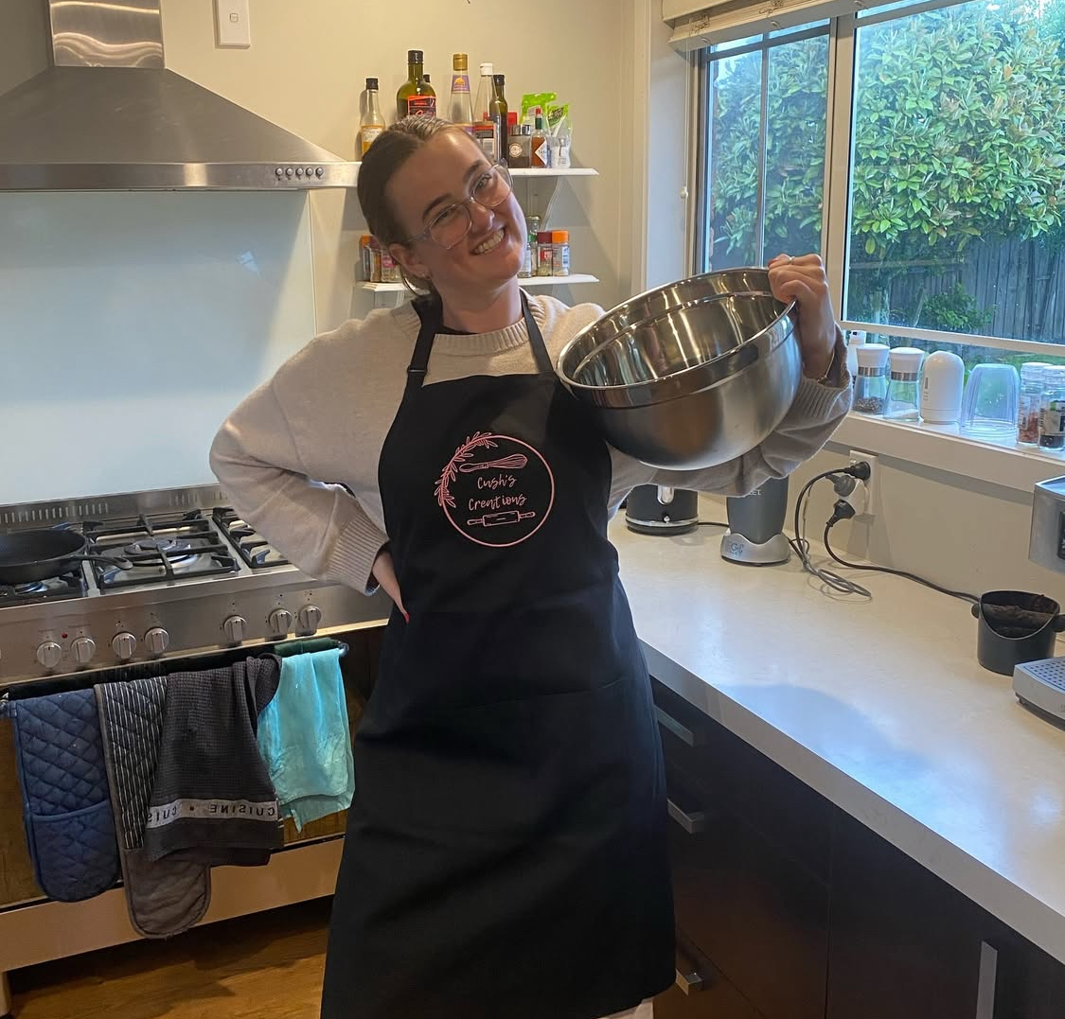

Then The Little Apron was born, representing a new chapter and most importantly a new apron. From being that kid in the kitchen, to learning, to working, to where I am now. The brand signifies the journey I’ve been on, those involved and the love I have for it.
[photo of cush in The Little Apron apron]
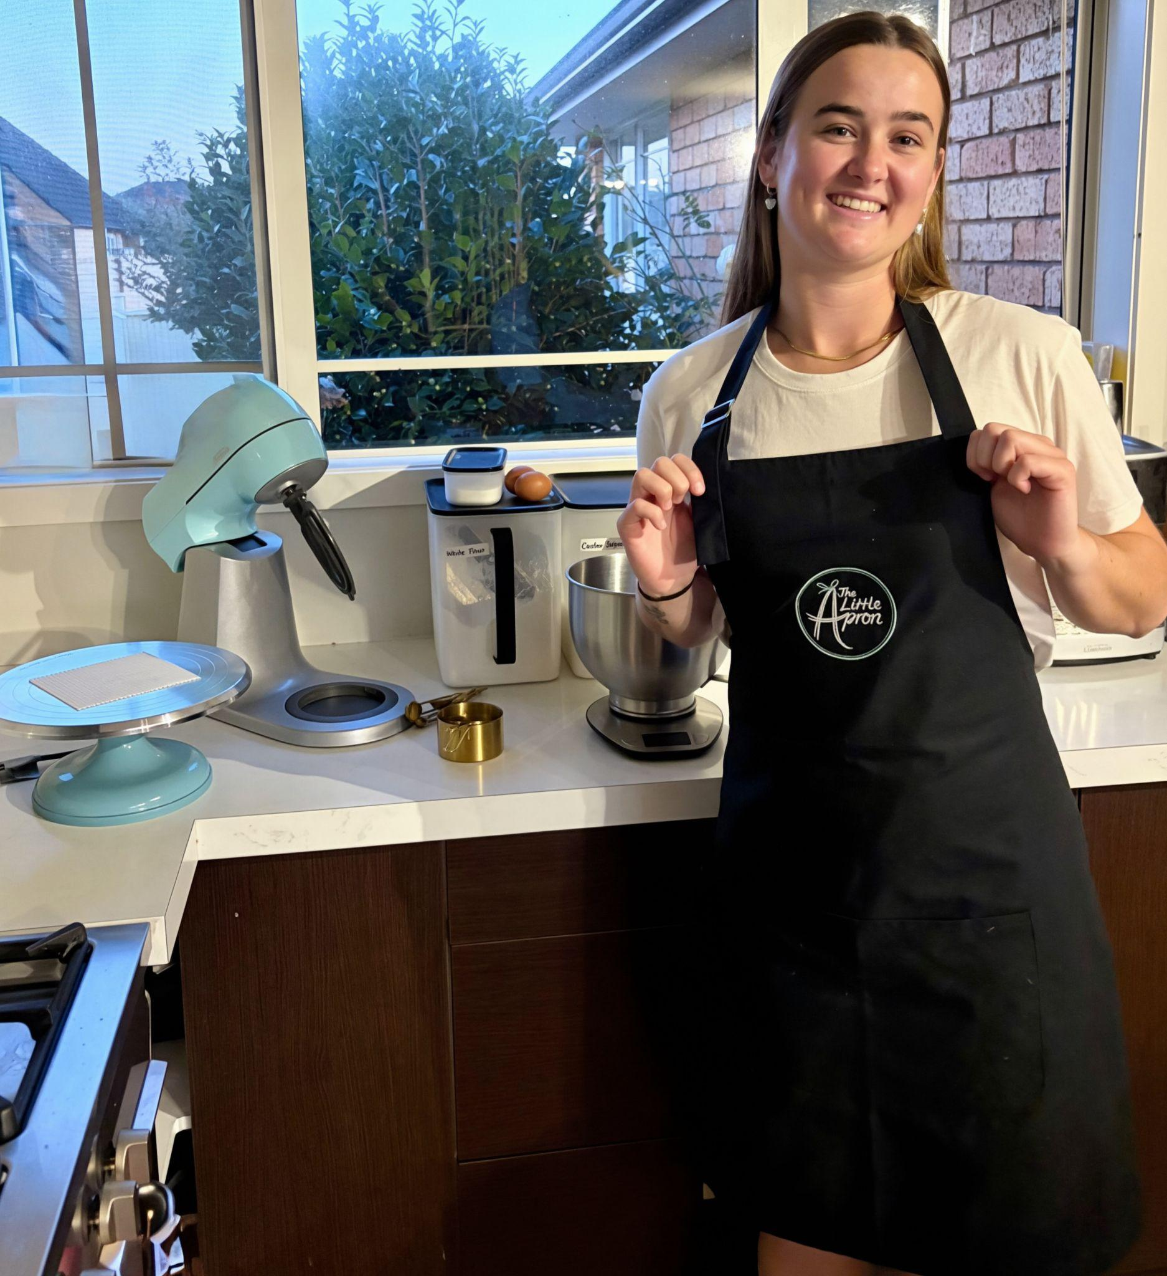

SWEET STUFF
Custom cakes, cupcakes and more
Explore our range of cakes and cupcakes, or do-it-yourself. Whether you’re planning something extra special or keeping it sweet and simple, The Little Apron is here to make every celebration that little bit sweeter.

[in their own little blocks to click through to the corresponding pages]
Signature cakes
Our most-loved cake styles with set pricing, designed to make celebrations effortless

Cupcakes
Perfect for birthdays, school celebrations, gifting, and little sweet cravings or even that little something extra when the cake is just not enough.

DIY kits
The perfect hands-on activity for little bakers and busy families. All the fun of decorating, without the stress of baking.

[one full block]
Have another cake design in mind?
Let’s make something special together. We’d love to help bring your cake to life.
[custom cake enquiry form]
[background image with a tile in the middle with the headings and button on it]
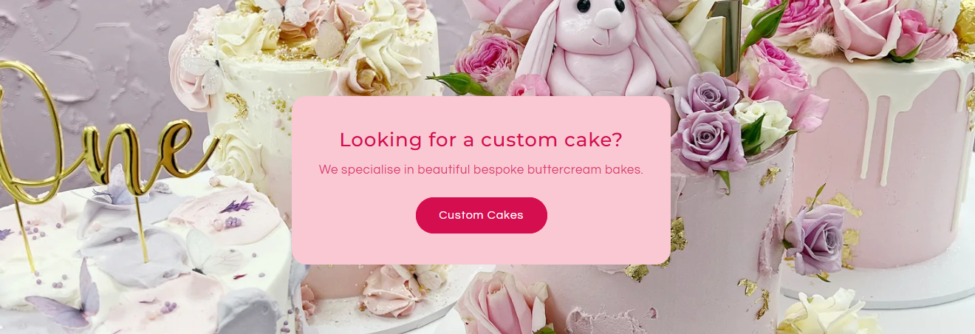

SIGNATURE CAKES

Canvas
From $40.00
Description
Price
4” 2 layered - $40
4” 4 layered - $60
6” 2 layered - $75
6” 4 layered - $100
8” - $220
[Size drop down]
- 4” 4 layered
- 6” 4 layered
- 8” 4 layered
[Cake flavour drop down]
- Vanilla
- Chocolate
- Banana
- Lemon
- Carrot
- Raspberry white choc

Unicorn
Description
Price
- 4” 4 layered - $115
- 6” 4 layered - $190
- 8”4 layered - $240
[Size drop down]
- 4” 4 layered
- 6” 4 layered
- 8” 4 layered
[Cake flavour drop down]
- Vanilla
- Chocolate
- Banana
- Lemon
- Carrot
- Raspberry white choc
[piping colour drop down]
- Pink
- Blue
- Green
- Mix of pastels
- Other (email us with your order number)

Drip
Description
Price
- 4” 4 layered - $105
- 6” 4 layered - $180
- 8” 4 layered - $210

Floral
Description
Price
- 4” 4 layered - $110
- 6” 4 layered - $180
- 8” 4 layered - $225

Vintage piped (round)
Description
Price
- 4” 4 layered - $100
- 6” 4 layered - $170
- 8” 4 layered - $215
[Size drop down]
- 4” 4 layered
- 6” 4 layered
- 8” 4 layered
[Cake flavour drop down]
- Vanilla
- Chocolate
- Banana
- Lemon
- Carrot
- Raspberry white choc
[piping colour drop down]
- Pink
- Blue
- Green
- Other (email us with your order number)

Vintage piped (heart)
Description
Price
- 6” 4 layered - $170
- 8” 4 layered - $215
[Size drop down]
- 6” 4 layered
- 8” 4 layered
[Cake flavour drop down]
- Vanilla
- Chocolate
- Banana
- Lemon
- Carrot
- Raspberry white choc
[piping colour drop down]
- Pink
- Blue
- Green
- Other (email us with your order number)

Vintage bow (round)
Description
Price
- 4” 4 layered - $105
- 6” 4 layered - $175
- 8” 4 layered - $220
[Size drop down]
- 4” 4 layered
- 6” 4 layered
- 8” 4 layered
[Cake flavour drop down]
- Vanilla
- Chocolate
- Banana
- Lemon
- Carrot
- Raspberry white choc
[piping colour drop down]
- Pink
- Blue
- Green
- Other (email us with your order number)

Vintage bow (heart)
Description
Price
- 6” 4 layered - $175
- 8” 4 layered - $220
[Size drop down]
- 6” 4 layered
- 8” 4 layered
[Cake flavour drop down]
- Vanilla
- Chocolate
- Banana
- Lemon
- Carrot
- Raspberry white choc
[piping colour drop down]
- Pink
- Blue
- Green
- Other (email us with your order number)

Chocolate lover
Description
Ganache, choc on top and choc icing
Price
- 4” 4 layered - $120
- 6” 4 layered - $190
- 8” 4 layered - $225

Baby Bean
Description
Price

Hearts & Buttercream
Description
Price
- 4” 4 layered - $100
- 6” 4 layered - $170
- 8” 4 layered - $215

Mini me
Description
4 inch cakes…
Price

On a budget?
Include blocks for:
Cupcakes
DIY cake kit
Canvas cake
Cheaper cake options 100>

ORDER
- Can we somehow reduce the length of the form? Like they click “more” or something to see the entire thing?
- Add in a block after the form before the footer linking back to the Our Story
  - Get to know your baker
- Follow along on socials
  - Link to Instagram showcasing some of my latest posts

